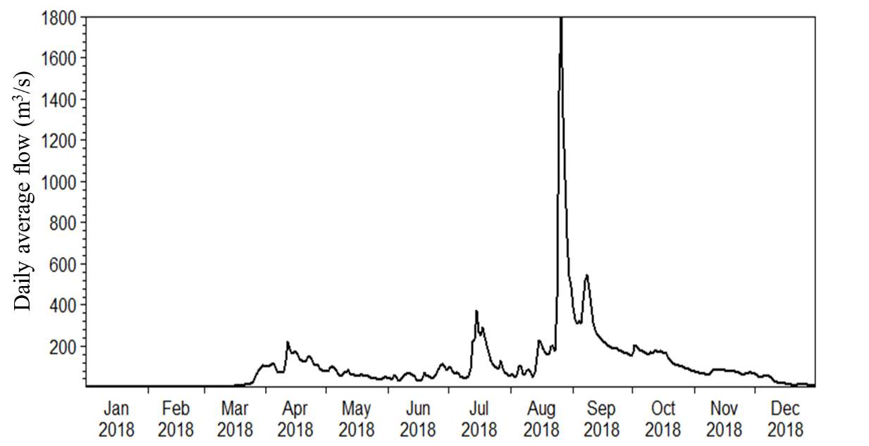
Fig. S-1 Daily average flow (m³/s) at Dashanzuizi Station in 2018

